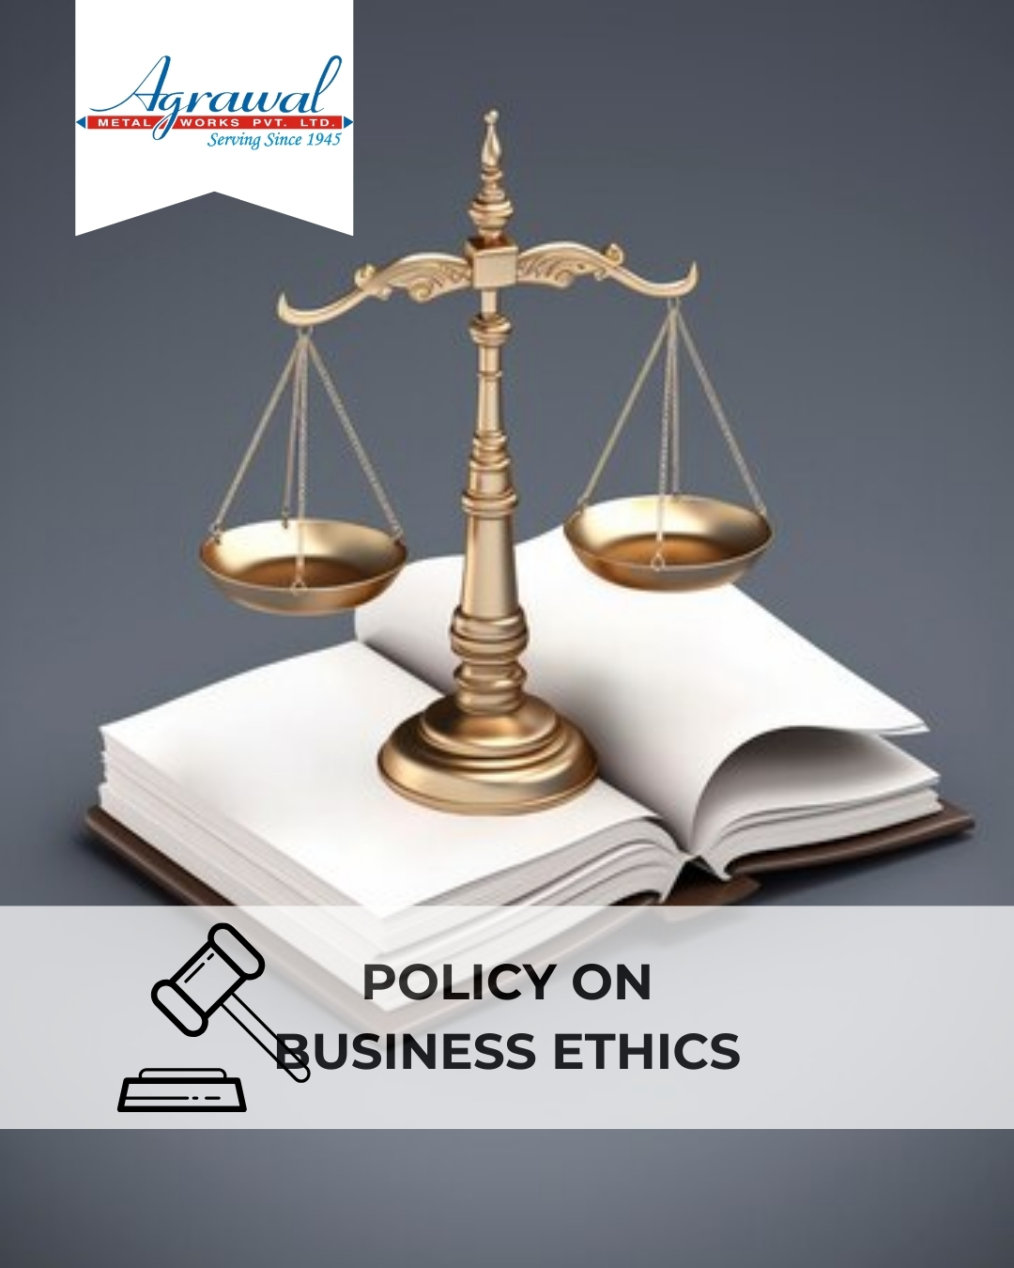

TABLE OF CONTENTS
INTRODUCTION 2
SCOPE 2
POLICY STATEMENT 3
KEY FOCUS AREAS 3
COMMITMENT AND GOALS 4
HARMONIZING ETHICAL PRACTICES WITH SUSTAINABLE DEVELOPMENT GOALS 5
EXAMPLES AND GUIDANCE 5
CONTINUOUS IMPROVEMENT 7
ADDRESSING POLICY VIOLATIONS 7
RESPONSIBILITIES 8
REVIEW MECHANISM 9
REVISION HISTORY 9
EMPLOYEE ACKNOWLEDGMENT FORM 10

INTRODUCTION

At Agrawal Metal Works Pvt. Ltd., ethical conduct is the foundation of our business operations and success. As a prominent manufacturer of Copper & Copper Alloy Foils, Strips & Sheets, Copper and Brass Round and Flatted Wires, and Fine Grain Brass Ingots, we are committed to uphold the highest standards of integrity, accountability, and ethical behavior in all aspects of our work.

Our Business Ethics Policy is designed to guide our actions and decisions, ensuring that we operate with honesty, transparency, and respect for all stakeholders, including employees, customers, suppliers, and the communities in which we operate. This policy reflects our dedication to foster an ethical culture where every individual is encouraged to act with integrity and responsibility. By adhering to these principles, we aim to build trust, maintain our reputation, and contribute positively to society. At Agrawal Metal Works, we believe that a strong ethical foundation is key to achieve sustainable growth and excellence in everything we do.

SCOPE

This Policy is applicable to following sites and all of its employees, workers, sub-contractors and other stakeholders:

Sr. No. | Site | Address
1 | Agrawal Metal Works Pvt. Ltd. | SP-144, RIICO Ind. Area, Phase-1, Bhiwadi – 301019, Maharastra, India
2 | Agrawal Metal Works Pvt. Ltd. | Jhajjar Road, Rewari-123401, Haryana, India
3 | Agrawal Metal Works Pvt. Ltd. | 205, “Arunachal Building” 19, Barakhamba Road –110001, New Delhi, India

POLICY STATEMENT

At Agrawal Metal Works Pvt. Ltd., we are committed to ethical conduct and integrity in all our business practices. We are committed to maintain the highest standards of honesty and fairness, creating a workplace culture of responsibility and integrity. Using FY 2019-20 as our baseline year, we are determined to measure our progress and ensure continuous improvement. By following these ethical principles, we strive for sustainable growth, strong relationships, and meaningful contributions to society.

KEY FOCUS AREAS
- Anti-Corruption: Maintain zero tolerance for bribery, facilitation payments, and any corrupt practices. Conduct all business with transparency and in line with legal and ethical standards.
- Conflict of Interest: Require disclosure of any personal or financial interest that may interfere with professional responsibilities. Decisions must remain impartial and in the company’s best interest.
- Fraud Prevention: Strengthen internal controls and accountability to prevent fraud. Encourage a speak-up culture through secure and confidential reporting mechanisms.
- Anti-Money Laundering: Implement due diligence on financial transactions and third-party engagements to identify and prevent suspicious or unlawful activity.
- Information Security: Safeguard confidential company, employee, and client data. Ensure responsible access, storage, and communication of sensitive information.
- Fair Business Conduct: Comply with antitrust and competition laws. Avoid unfair trade practices and promote ethical, transparent dealings with all stakeholders.
- Transparent Recordkeeping: Maintain accurate and honest records across all operations to support accountability, traceability, and compliance.
- Respect for Stakeholder Trust: Build long-term relationships through ethical conduct with customers, suppliers, partners, and communities.

COMMITMENT AND GOALS

- Maintain a zero-tolerance policy for bribery and corruption and ensure strict compliance with anti-corruption laws and company policies
- Maintain inclusion and compliance of anti-bribery clauses into 100% of supplier and partner contracts by FY 2029-30.
- Maintain 100% employee participation in annual anti-corruption training programs by FY 2029-30.
- To ensure all employees understand the importance of disclosing potential conflicts.
- Maintain 100% employee compliance rate in reporting potential conflicts of interest by FY 2029-30.
- To ensure that 100% of employees annually complete and submit conflict of interest disclosure form.
- To implement a robust internal audit system to detect and prevent fraudulent activities within the organization.
- Conduct two comprehensive fraud risk assessments annually, aiming for zero incidences of detected fraud by FY 2029-30.
- Develop and maintain a comprehensive anti-money laundering (AML) policy, including regular training for employees on AML practices.
- Maintain a 100% compliance rate with AML regulations through regular audits and training sessions by FY 2029-30.
- To review and update anti-competitive practices policy annually to reflect the latest regulations and industry standards.
- Maintain zero number of false positive alerts in AML monitoring systems by FY 2029-30.
- To provide annual training regularly on anti-competitive practices to achieve 100% of employees are in relevant departments by FY 2029-30.
- To implement advanced information security measures and regular training to protect sensitive company and customer data.
- Conduct annual Information Security audits, aiming to maintain zero data breaches by FY 2029-30.
- Train 100% of relevant employees on document retention and compliance annually.

- Achieve and maintain at least 90% stakeholder satisfaction (across customers, suppliers, and partners) through annual feedback surveys by FY 2029-30.

HARMONIZING ETHICAL PRACTICES WITH SUSTAINABLE DEVELOPMENT GOALS

At Agrawal Metal Works Pvt Ltd, our Ethics policy aligns with the following given SDGs.
 | 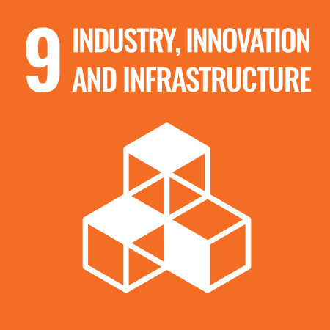 |  | 

EXAMPLES AND GUIDANCE
To support clear understanding and consistent implementation, the following examples and guidance provide practical direction under each ethical focus area:
- Anti-Corruption
- Example: A supplier offers an expensive gift to senior executive during contract negotiations.
- Guidance: The executive must decline the gift and report the incident to the compliance officer. Accepting or soliciting gifts, bribes, or personal benefits is strictly prohibited under our anti-corruption policy.
- Conflict of Interest
- Example: An employee is tasked with vendor selection and one of the bidders is owned by a close family member.
- Guidance: The employee must disclose the relationship and recuse themselves from the decision-making process. All potential conflicts must be reported to ensure impartial and unbiased operations.

- Fraud
- Example: A warehouse supervisor notices discrepancies in inventory records that suggest materials are being diverted for personal use.
- Guidance: The matter must be reported immediately for investigation. All employees must help prevent, detect, and report any fraudulent activity.
- Money Laundering
- Example: A customer proposes paying for a large machinery order using multiple cash transactions from different sources.
- Guidance: This is a red flag for money laundering. The transaction should be reported and not processed without proper review. Employees must comply with AML procedures and identify suspicious financial behaviour.
- Information Security
- Example: An employee shares internal pricing data with a third-party consultant via an unsecured email platform.
- Guidance: Company information must only be shared through approved, secure channels. Confidential data must be protected at all times, in line with company information security protocols.
- Fair Business Conduct
- Example: A sales manager considers undercutting a competitor by spreading false information about their product to win a deal.
- Guidance: Such behaviour is unethical and unacceptable. Employees must maintain integrity, treat competitors fairly, and avoid deceptive business practices.
- Transparent Recordkeeping
- Example: A finance team member is asked to delay expense reporting to make the quarterly financials appear stronger.
- Guidance: All records must be accurate, complete, and updated in real time. Misreporting or manipulating data compromises transparency and legal compliance.
- Respect for Stakeholder Trust
- Example: A supplier complains that their concerns about late payments are being ignored by the procurement team.
- Guidance: Concerns from any stakeholder must be acknowledged and addressed promptly. Employees must engage professionally and uphold trust through fair, respectful communication and actions.

CONTINUOUS IMPROVEMENT

At Agrawal Metal Works, Ethical Conduct practices are continuously enhanced to stay aligned with evolving regulations, industry standards, and emerging risks. A strong culture of integrity is embedded across all levels of the organization, ensuring transparency, accountability, and regulatory compliance.
- Ongoing Training & Awareness: Employees undergo annual training on key ethical topics, including anti-corruption, conflict of interest, fraud prevention, anti-money laundering (AML), and information security.
- Risk Assessments & Independent Audits: Regular internal reviews and third-party audits help identify potential ethical risks, evaluate policy effectiveness, and drive corrective actions.
- Collaborative Compliance Engagement: Active participation in industry forums and regulatory dialogues supports alignment with best practices and ethical norms.
- Advanced Monitoring & Reporting Systems: Secure digital tools and automated monitoring mechanisms strengthen fraud detection, compliance management, and incident reporting.
- Feedback & Transparency Culture: Open channels for feedback empower employees and stakeholders to share concerns or suggestions, driving continual ethical improvements.

ADDRESSING POLICY VIOLATIONS

Agrawal Metal Works maintains a zero-tolerance stance on all forms of ethical misconduct, including corruption, conflicts of interest, fraud, money laundering, and data breaches. Any confirmed violations are met with strict and proportionate disciplinary measures to uphold ethical standards.

- Reporting Mechanism
- Employees, suppliers, and external stakeholders are encouraged to report suspected violations through a secure and confidential whistleblower system that guarantees anonymity and protection against retaliation.
- All reported concerns are treated with the utmost confidentiality and addressed through prompt and thorough investigation.
- Investigation & Disciplinary Actions
- Investigations are led by the Compliance Officer, with support from internal teams or external experts as needed.
- Confirmed violations may result in disciplinary actions such as warnings, suspension, termination, or legal action.
- Suppliers found in violation of ethical standards may face contract suspension, financial penalties, or disqualification from future engagements.
- Corrective & Preventive Actions
- Following any ethical breach, corrective actions such as policy updates, enhanced controls, or targeted training are implemented to prevent recurrence.
- Insights gained from incidents are integrated into risk assessments and policy reviews, contributing to stronger ethical governance and resilience.

RESPONSIBILITIES
The ethical framework at Agrawal Metal Works is supported by dedicated governance structures:
- Ethics Committee: A cross-functional body responsible for policy formulation, compliance oversight, and ethical risk management.
- Ethics Officer: Appointed to manage daily ethical issues, conduct training, receive grievances, and report serious matters to the Committee and Management.
- Departmental Heads: Responsible for enforcing ethics policies within their teams.
- All Employees and Suppliers: Must adhere to the ethics code and report violations.

REVIEW MECHANISM

To ensure ongoing alignment with ethical standards:
- Annual Review: The annual review of this policy is conducted by the Compliance Officer to assess policy relevance, effectiveness, and compliance with updated laws.
- Internal Audits: Ethics compliance is part of quarterly internal audits, with reports submitted to senior management.
- Stakeholder Feedback: Ethics performance is reviewed using feedback from employees, suppliers, and external partners.
- Documentation: All review outcomes, improvement actions, and policy changes are recorded and archived for accountability.

REVISION HISTORY

Amendment of Revision No. | Effective Date | Details of Amendment of Revision
00 | 01.01.2023 | New Policy Draft
01 | 01.01.2024 | Scope
01 | 01.01.2024 | Commitment and Goals
01 | 01.01.2024 | Review Mechanism
02 | 01.01.2024 | Key Focus Areas
02 | 01.01.2024 | Responsibilities
02 | 01.01.2024 | Examples and Guidance
02 | 01.01.2024 | Continuous Improvement
02 | 01.01.2024 | Addressing Policy Violations

REV. No. 02

LAST REVIEW DATE: 01.01.2025 NEXT REVIEW DATE: 01.01.2026
APPROVED BY:

EMPLOYEE ACKNOWLEDGMENT FORM

I acknowledge that I have received, read, and understood the Business Ethics Policy of Agrawal Metal Works Pvt. Ltd. I agree to uphold the principles outlined in this policy, including preventing corruption, managing conflicts of interest, combating fraud, ensuring compliance with anti-money laundering regulations, and safeguarding information security.
I understand that it is my responsibility to adhere to this policy in all professional activities and to report any ethical concerns or violations through the designated reporting channels. I acknowledge that non-compliance may result in disciplinary action in accordance with company regulations.
By signing this acknowledgment, I confirm my commitment to integrity, transparency, and ethical conduct in all aspects of my work.

Employee Name  Employee ID  Date  Signature | :_______________________________  :_______________________________ :________________________________  : _______________________________

